Министерство образования Красноярского края
краевое государственное бюджетное
профессиональное образовательное учреждение
«Красноярский аграрный техникум»

РАССМОТРЕНО:  на заседании цикловой  комиссии общеобразовательных дисциплин  протокол №__  «__»_____________2019 г.  Председатель цикловой комиссии  _____________ Т. Л. Григорьева | УТВЕРЖДАЮ:  зам. директора по УР  Красноярского аграрного техникума  ______________Т. М. Тимофеева  «____»________________2019 г.

Методическое пособие для выполнения самостоятельных работ по дисциплине: «Иностранный язык»

Курс 2
Специальность «Страховое дело», «Земельно-имущественные отношения»
Составил: О.А. Халекова

Красноярск 2019

Содержание

Указания по выполнению самостоятельной работы ____________________3
«Земельно-имущественные отношения»
Тема «Средства массовой информации »_____________________________4
Тема «What is a computer?»» _____________________________________ _6
Тема «Видовременные формы глагола»_____________________________ 8
Тема «Family relation»____________ _______________________________ 9
«Страховое дело»
Тема «Ситуации общения в аэропорту, на вокзале»___________________12
Тема «Ориентирование в российском и английском аэропорту»________ 14
Тема «Развитие навыков диалогической речи»______________________ 17
Список используемой литературы и интернет ресурсов _______________18

Указания по выполнению самостоятельной работы
Данные методические рекомендации по выполнению самостоятельной работы по дисциплине Иностранный язык предназначены для студентов очной формы обучения.
Самостоятельная внеаудиторная работа является обязательной, для каждого студента.
Внеаудиторная самостоятельная учебная деятельность - это вид учебной деятельности, которую студент совершает индивидуально или в группе без непосредственной помощи и указаний преподавателя, руководствуясь сформированными представлениями о порядке и правильности выполнения работ.
Задания для самостоятельной работы необходимо выполнить в отдельной тетради, чернилами синего цвета. Для замечаний преподавателя необходимо оставить поля.
Перед началом выполнения грамматических заданий внимательно ознакомиться с теоретическим материалом и выполнить упражнения.
При работе с текстом проработать новую лексику, выписав незнакомые слова в тетрадь с переводом и транскрипцией, а затем прочитать и перевести текст.
После выполнения всех заданий тетрадь необходимо сдать преподавателю для проверки. После проверки, при наличии ошибок необходимо исправить все недочеты.

Тема «Средства массовой информации»
Text «Mass media»
- Прочитайте текст
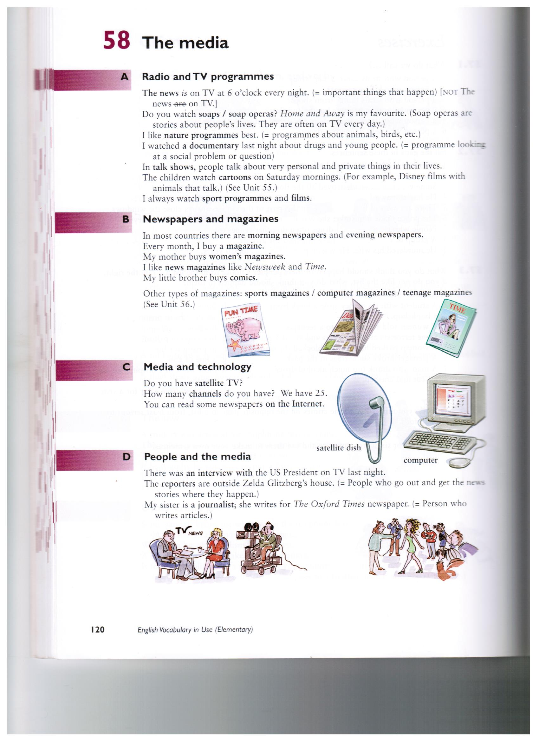
- Выполните задания по тексту
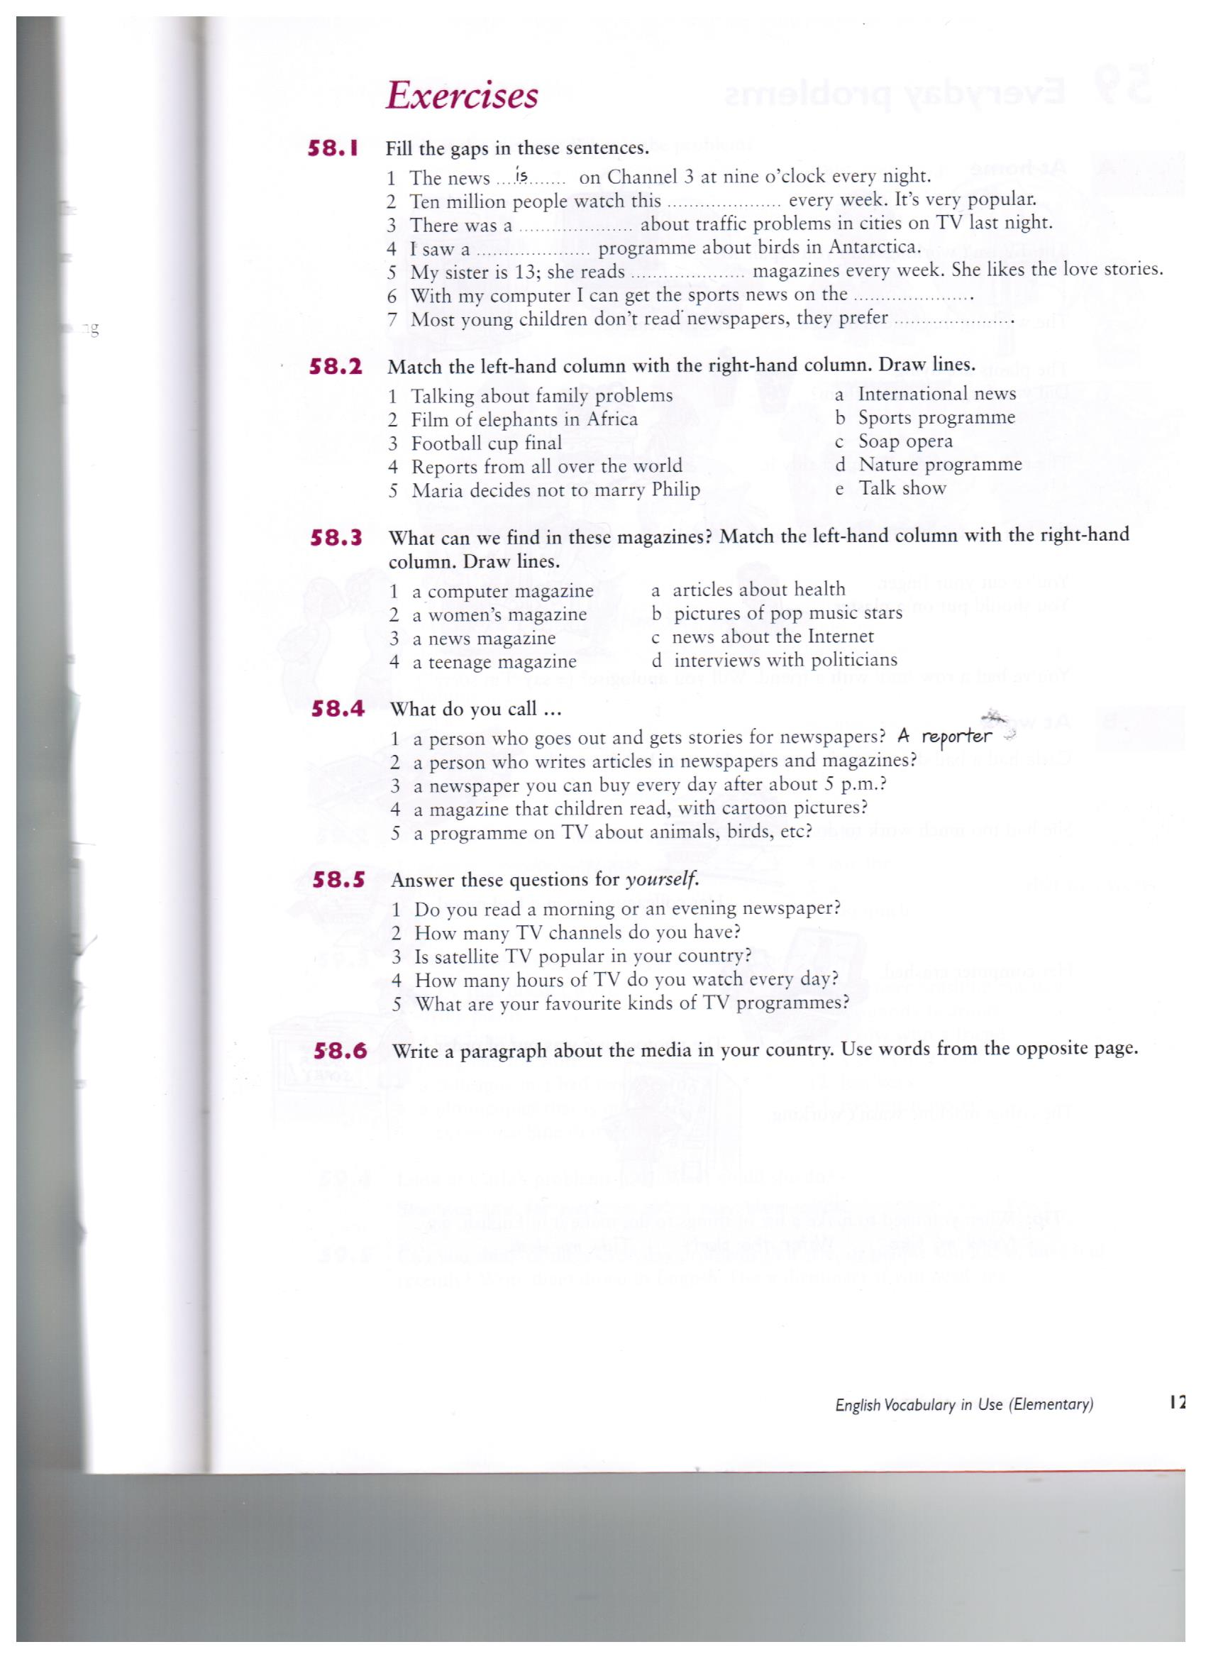

Тема «What is a computer?»
- Прочитайте текст и выполните следующие задания:
Computer is a device for processing information. Computer has no intelligence by itself and is called hardware. A computer system is a combination of four elements: • Hardware • Software • Procedures • Data/information Software are the programs that tell the hardware how to perform a task. Without software instructions, the hardware doesn't know what to do. The basic job of the computer is the processing of information. Computers take information in the form of instructions called programs and symbols called data. After that they perform various mathematical and logical operations, and then give the results (information). Computer is used to convert data into information. Computer is also used to store information in the digital form.
1. Ответьте на вопросы:
1. What does the term «computer» describe?
2.Is computer intelligent?
3.What are four components of computer system?
4.What is software?
5.What's the difference between the hardware and software?
6.In what way terms «data» and «information» differ?
7.How does computer convert data into information?
2. Какие из приведенных ниже терминов имеют аналоги в русском языке? computer, diskette, metal, processor, scanner, information, data, microphone, printer, modem, Internet.
3. Какие из приведенных ниже утверждений верны/неверны? Аргументируйте свой ответ, опираясь на текст.
1) Computer is made of electronic components so it is referred to as electronic device 2) Computer has no intelligence until software is loaded.
3) There are four elements of computer system; hardware, software, diskettes and data.
4) Without software instructions hardware doesn't know what to do.
5) The software is the most important component because it is made.
6) The user inputs data into computer to get information as an output.
7) Computer has no intelligence until software is loaded.

Тема «Видовременные формы глаголов»

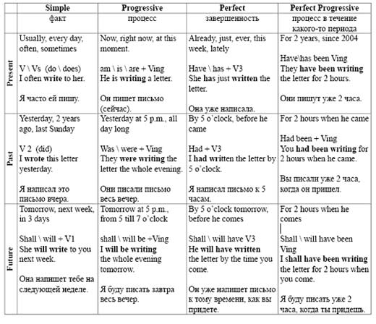

1Раскройте скобки. Употребите глагол в одном из настоящих времен.
1. Look! She ( wear) the same shoes as me.
2. Vegetarians are people who (not eat) meat.
3. Someone (take) my bicycle.
4. I often (see) him but I never (speak) to him.
5. I (buy) a new carpet. Come and look at it.
2.Раскройте скобки. Употребите глагол в одном из прошедших времен.
1. When I arrived at his house he still (sleep).
2. A few months ago they (begin) to build a new block of flats in this street.
3. They (walk) in the park for an hour when it began to rain.
4. When the door-bell (ring) he (stand up) and (go) to the door.
5. The fire still (burn) at 6 o’clock this morning.
3.Раскройте скобки. Употребите глагол в одном из будущих времен.
1. This time next month I (bath) in the Baltic sea.
2. By the 8th of April my mother (work) at school for twenty years.
3. I’m tired. I think, I (go) to bed.
4. I (work) in the library all day tomorrow.
5. At four o’clock on Tuesday afternoon we (fly) over Paris.
4.Определите видо -временную форму глагола.
1. Том вернется из кинотеатра к пяти часам.
2. Где твой брат? - Он только что пришел домой. Он сейчас принимает душ.
3. Вы когда-нибудь читали «Унесенные ветром»? - Я как раз сейчас читаю этот роман.
4. Я всегда прихожу домой без четверти девять.
5. Я приду в три часа. – Хорошо, я буду тебя ждать.

Тема «Family relations»
- Прочитайте и переведите текст
How could you describe the word "family"? First of all "family" means a close unit of parents and their children living together. But we shouldn't forget that it is a most complex system of relationships. Family relationships are rarely as easy as we would like, and very often we have to work hard at keeping them peaceful.
When do people usually start a family? This question doesn't have a definite answer. In the 18th, 19th and at the beginning of the 20th century people used to get married at the age of 18 or even 16. If a girl about 23 or more wasn't married, she was said to be an old maid or a spinster. That might have turned out a real tragedy for her family which usually brought up more than three children, because in some cases a successful marriage was the only chance to provide a good life for the daughter and to help her family. Despite the fact that the girl was so young, she was already able to keep the house, take care of her husband and raise children. To feel the time, its culture and customs I advise you to read a wonderful novel or see a breathtaking film "Pride and Prejudice". Though the story takes place at the turn of the 19th century, it retains fascination for modern readers, revealing some problems which may be urgent in the 21st century.
But life's changing as well as people's style of life. Nowadays we have got much more freedom in questions concerning family. It is natural to get married at the age of 20 up to 30; however, some people prefer to make a career first and only after that start a family when they are already in their forties. Moreover, there are many cases when people prefer to live together without being married. There are some reasons for this phenomenon. Firstly, it is difficult to juggle a family life with studies at school or university. But without good education it is practically impossible to find a suitable well-paid steady job. It's a must to get a higher education, but by this moment you are already 22—24 years old. After that you seek for a well-paid job to live independently, which takes about 3—5 years. Now you see why people in the 21st century do not hurry to get married.
There is also another difference between old and modern families. Nowadays it is very unusual to find three generations living under one roof as they used to do in the past. Relatives, as a rule, live separately and don't often meet one another. This fact sharply hurts an older generation. Our parents and grandparents usually suffer from lack of attention and respect from their children and grandchildren, although they try not to show it. They really don't need much, just a telephone call or a visit once a week will make them happy.
There are two basic types of families. A nuclear family — a typical family consisting of parents and children. A single-parent family consists of one parent and children. Nowadays there are very few people who have never divorced. Today the highest divorce rate in the world has the Maldive Republic. The United States of America take the third place. Russia is at the ninth place. What are the reasons of great numbers of divorce? Let us name some of the most common and serious ones.
• Occurrence of adultery once or throughout the marriage. The unfaithful attitude towards a spouse destroys the relationship and leads to a final separation.
• Communication breakdown. After some time of living under one roof spouses find out that they are absolutely incompatible. Constant clashes, brawls and squabbles cause serious problems. The differences grow as a snowball and can't be already settled by kisses or hugs.
• Physical, psychological or emotional abuses. When a person taunts, humiliates, hits the children or his spouse, it can't but end with a divorce.
• Financial problems. It sounds lamentably, but sometimes love alone can't guarantee well-being, whereas money can solve many of your problems. So when a couple lacks it, their relations become more and more complicated, their priorities change and the relationships end.
• Boredom. A lot of couples get bored of each other after 7 or more years of marriage. Boredom may become the reason of constant quarrels and adultery which inevitably leads to a divorce.
However, it goes without saying, in most cases married couples succeed in solving all the problems and keep living in peace and happiness.

- Ответьте на вопросы
1. How many members are there in your family?
2. At what age did your parents get married?.
3. Do you think it is possible for a modern girl/boy of eighteen to start a family?
4 What is a "woman's place" and what is a "man's place" in the family?
5. Do you agree with the statement that unhappy couples with children should stay together until the children are grown?

«Страховое дело»
Тема «Ситуации общения в аэропорту, на вокзале»
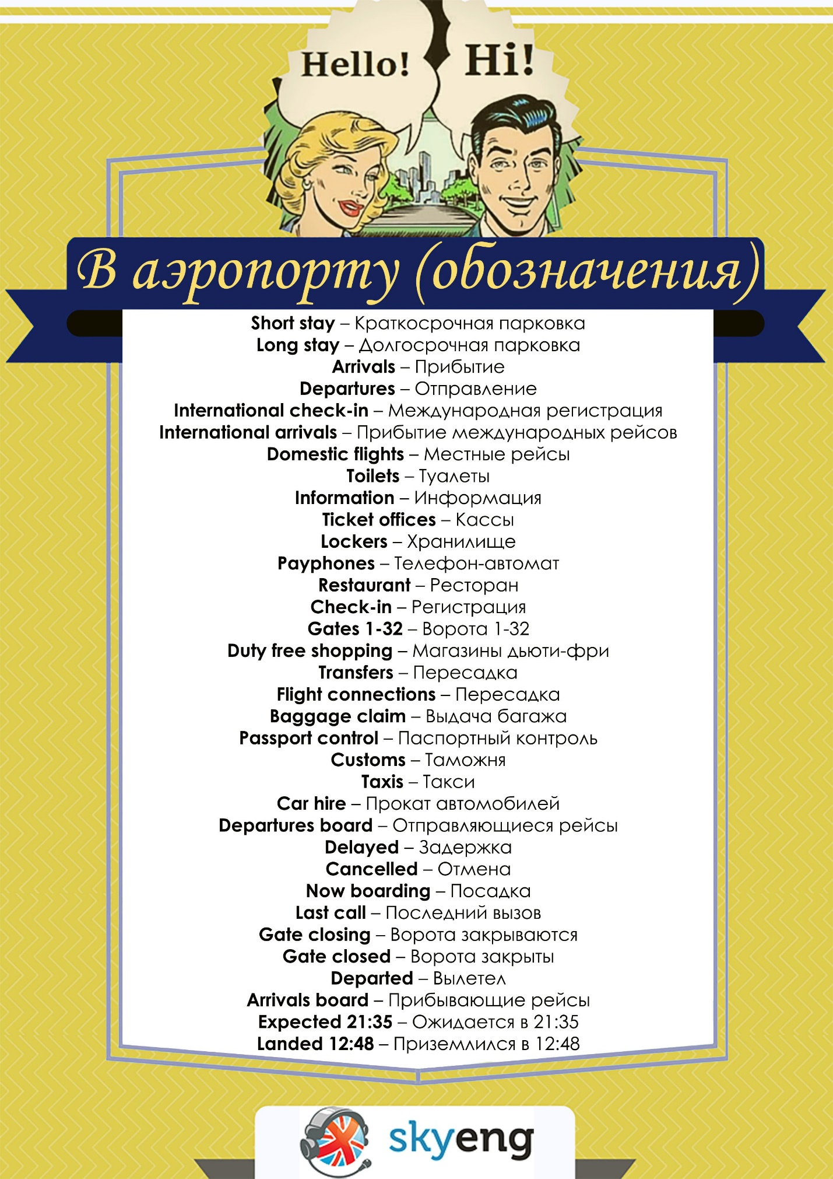
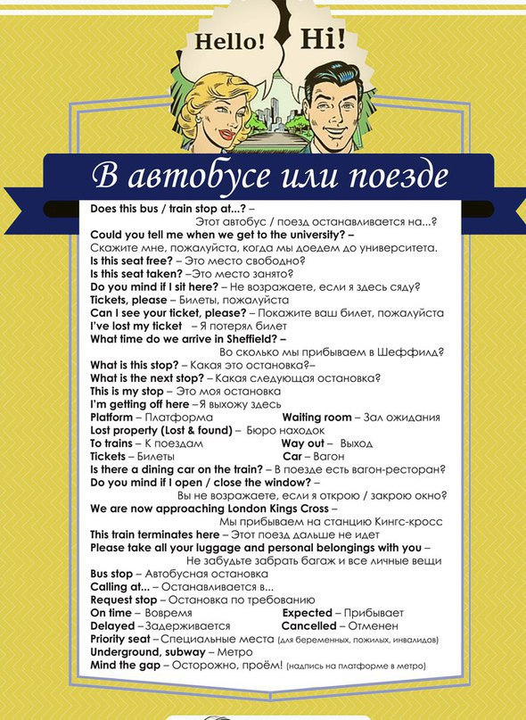
Составьте диалог, используя новые выражения и обозначения.

Тема «Ориентирование в российском и английском аэропорту»
Прочитайте текст и выполните задания.
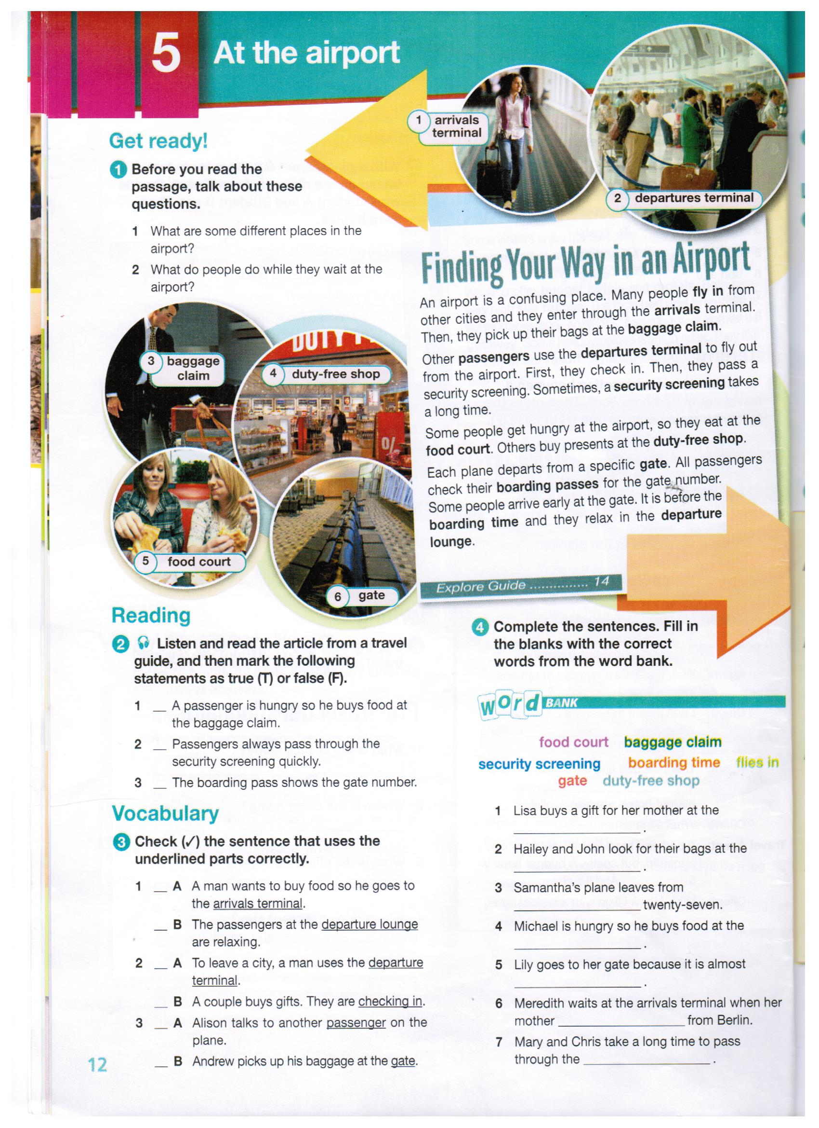
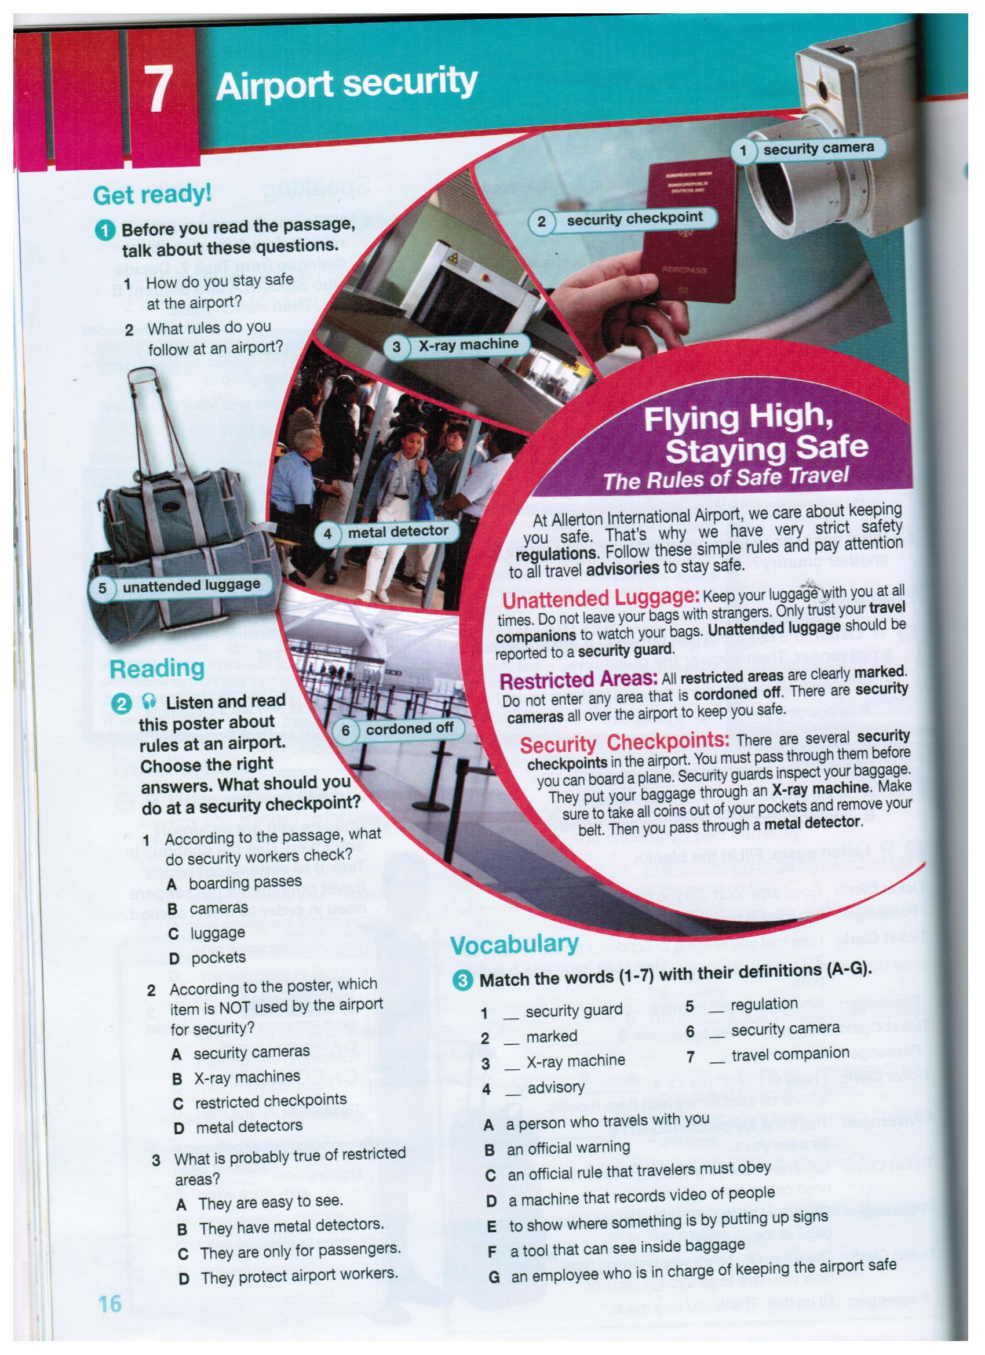

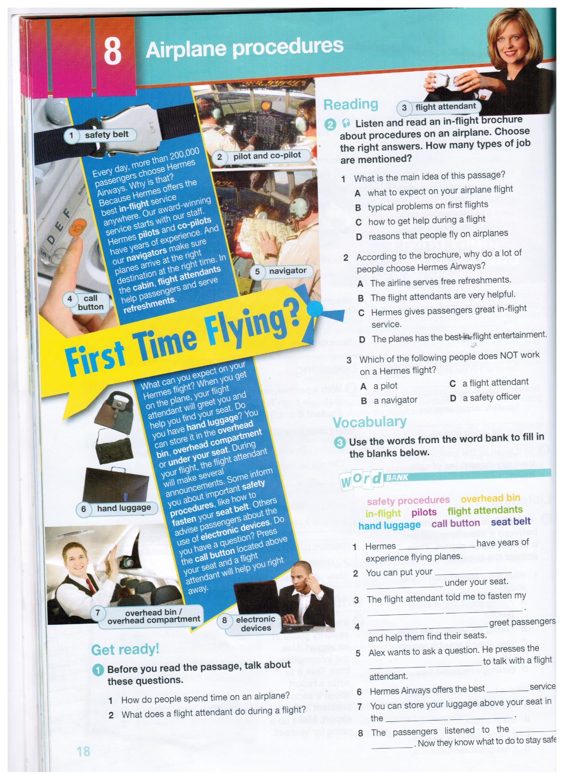

Тема «Развитие навыков диалогической речи»
- Прочитайте и переведите диалог
At the check-in counter
- Hi. I’d like to check in for the flight to Vienna, please.
- Hi. Welcome to Italian Airlines. Can I see your ID and your tickets, please?
- Sure. Here they are.
- Thanks. How much baggage do you have?
- I have two bags and one suitcase.
- Could your put your bags on the scales, please? … OK. Did you pack the baggage yourself?
- Yes, I did.
- Well. Your baggage exceeds the weight limit. It weighs 34 kilograms and I’m afraid you’ll have to pay additional fees for the extra weight, sir. The charge is 15 euros per kilogram.
- Never mind. I will pay for that.
- Ok. And do you have any hand luggage?
- I think I will carry my backpack and a fragile souvenir into the cabin.
- Let me have a look at them. OK, they are not heavy. Remember you are not allowed to carry any bottles, electrical goods or sharp things onto the aircraft. They should be placed in your baggage.
- No, there aren’t any prohibited items in my hand luggage.
- OK then. Here are the security tags for your hand luggage. Please attach them to your items. What kind of seat would you like to take: an aisle seat or a window seat?
- I’d rather prefer an aisle seat this time. It makes it easier to move around.
- Ok. No problem, sir. So your seat number is 9 F. Here is your boarding pass. When you hear the announcement about your flight departure, move to Gate 6 and your may board your aircraft. You will be boarding in one hour. Enjoy your flight!

Список используемой литературы и интернет ресурсов

Culturally Authentic Pictorial Lexicon: предлагается изображения, демонстрирующие истинное значение слова, упрощая для изучающих английский язык.
ManyThings: на этом сайте вы найдете викторины, игры в слова, загадки, и генератор случайных предложения, чтобы помочь студентам лучше понять английский как второй язык.
bab.la : Bab.la является очень веселым сайтом для ELL учащихся, с инструментами, как словарь и лексический словарь, дополненный викторинами, играми, есть форум сообщества.
ESL Основы: на этом сайте вы найдете бесплатное видео на английском как для студентов, так и преподавателей. Английское произношение (English Pronunciation): ресурс предлагает 13 различных учебных блоков для изучения и преподавания английского произношения.
BBC Изучение английского языка: на этом сайте от BBC студенты могут найти помощь по грамматике, лексике и произношению, с большим количеством ссылок на текущие события.
ESL Gold: действительно золотой с бесконечными ресурсами для обучения английскому языку. Студенты могут практиковать произношение, найти книгу для изучения, и даже поговорить с кем-то на английском языке на этом сайте.
Повторяйте за нами (Repeat after us): d этой онлайн-библиотеке студенты могут получить доступ к огромной коллекции английских текстов и записей.
Google Translate. ESL Cyber Listening Lab. Vocabulix: 'то онлайн-инструмент предназначен для работы с лексикой.
WordSteps : WordSteps позволяет создавать свои собственные коллекции слов, а также доступ к своему словарю с помощью мобильного устройства для изучения английского языка на ходу.
http://pro-spo.ru/internet/4176-internet-resursy-dlya-izucheniya-anglijskogo-yazyka

